**minkyeongk**

**테스트 • 30 MIN**

**Introduction to deep learning**

**최신 제출물 성적**

90%

**질문 1.**

What does the analogy “AI is the new electricity” refer to?

**1/1점**



AI runs on computers and is thus powered by electricity, but it is letting computers do things not possible before.



AI is powering personal devices in our homes and offices, similar to electricity.



Similar to electricity starting about 100 years ago, AI is transforming multiple industries.



Through the “smart grid”, AI is delivering a new wave of electricity.

**맞습니다**

Yes. AI is transforming many fields from the car industry to agriculture to supply-chain...

**질문 2.**

Which of these are reasons for Deep Learning recently taking off? (Check the three options that apply.)

**1/1점**



We have access to a lot more data.

**맞습니다**

Yes! The digitalization of our society has played a huge role in this.



We have access to a lot more computational power.

**맞습니다**

Yes! The development of hardware, perhaps especially GPU computing, has significantly improved deep learning algorithms' performance.



Deep learning has resulted in significant improvements in important applications such as online advertising, speech recognition, and image recognition.

**맞습니다**

These were all examples discussed in lecture 3.



Neural Networks are a brand new field.

**질문 3.**

Recall this diagram of iterating over different ML ideas. Which of the statements below are true? (Check all that apply.)

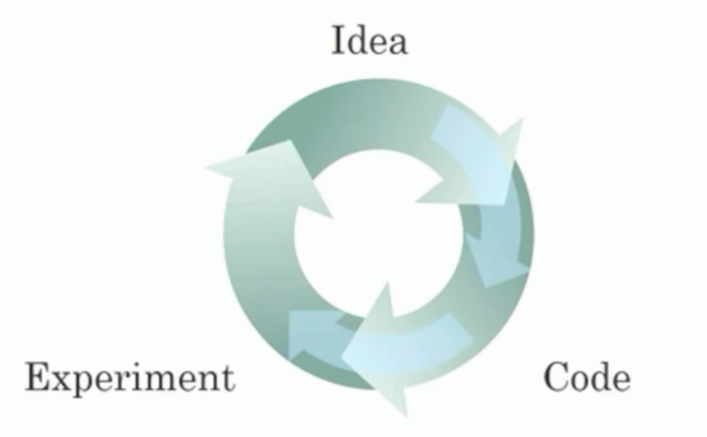

**1/1점**



Being able to try out ideas quickly allows deep learning engineers to iterate more quickly.

**맞습니다**

Yes, as discussed in Lecture 4.



Faster computation can help speed up how long a team takes to iterate to a good idea.

**맞습니다**

Yes, as discussed in Lecture 4.



It is faster to train on a big dataset than a small dataset.



Recent progress in deep learning algorithms has allowed us to train good models faster (even without changing the CPU/GPU hardware).

**맞습니다**

Yes. For example, we discussed how switching from sigmoid to ReLU activation functions allows faster training.

**질문 4.**

When an experienced deep learning engineer works on a new problem, they can usually use insight from previous problems to train a good model on the first try, without needing to iterate multiple times through different models. True/False?

**1/1점**



True



False

**맞습니다**

Yes. Finding the characteristics of a model is key to have good performance. Although experience can help, it requires multiple iterations to build a good model.

**질문 5.**

Which one of these plots represents a ReLU activation function?

**1/1점**



Figure 1:

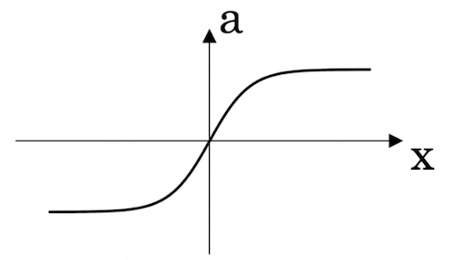



Figure 2:

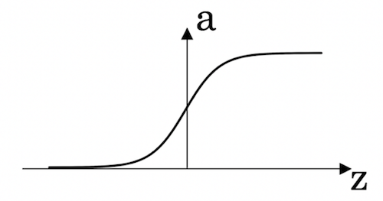



Figure 3:

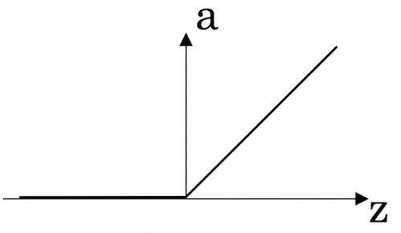



Figure 4:

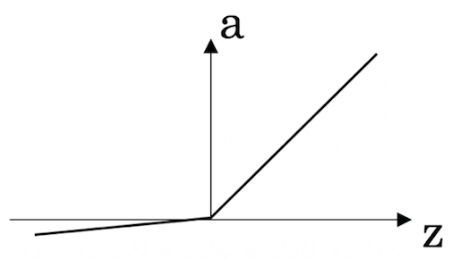

**맞습니다**

Correct! This is the ReLU activation function, the most used in neural networks.

**질문 6.**

Images for cat recognition is an example of “structured” data, because it is represented as a structured array in a computer. True/False?

**1/1점**



True



False

**맞습니다**

Yes. Images for cat recognition is an example of “unstructured” data.

**질문 7.**

A demographic dataset with statistics on different cities' population, GDP per capita, economic growth is an example of “unstructured” data because it contains data coming from different sources. True/False?

**1/1점**



True



False

**맞습니다**

A demographic dataset with statistics on different cities' population, GDP per capita, economic growth is an example of “structured” data by opposition to image, audio or text datasets.

**질문 8.**

Why is an RNN (Recurrent Neural Network) used for machine translation, say translating English to French? (Check all that apply.)

**0/1점**



It can be trained as a supervised learning problem.



It is strictly more powerful than a Convolutional Neural Network (CNN).



It is applicable when the input/output is a sequence (e.g., a sequence of words).

**맞습니다**

Yes. An RNN can map from a sequence of english words to a sequence of french words.



RNNs represent the recurrent process of Idea->Code->Experiment->Idea->....

정답을 모두 선택하지 않았습니다. > 이 보기도 정답임

**질문 9.**

In this diagram which we hand-drew in lecture, what do the horizontal axis (x-axis) and vertical axis (y-axis) represent?

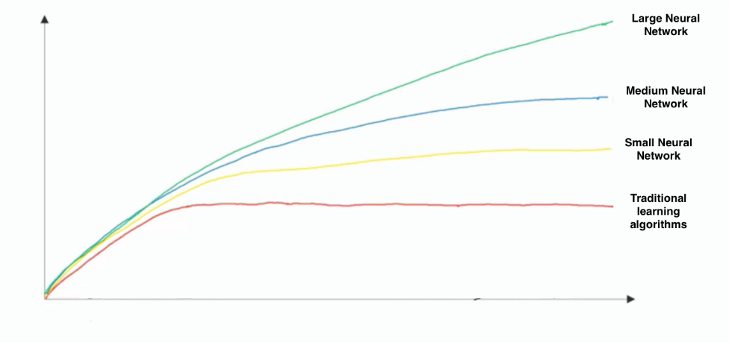

**1/1점**



* x-axis is the amount of data
* y-axis (vertical axis) is the performance of the algorithm.



* x-axis is the performance of the algorithm
* y-axis (vertical axis) is the amount of data.



* x-axis is the input to the algorithm
* y-axis is outputs.



* x-axis is the amount of data
* y-axis is the size of the model you train.

**맞습니다**

> 데이터가 적으면 engineering skill이 중요, 데이터 많은 경우 larger NN이 중요

**질문 10.**

Assuming the trends described in the previous question's figure are accurate (and hoping you got the axis labels right), which of the following are true? (Check all that apply.)

**1/1점**



Increasing the training set size generally does not hurt an algorithm’s performance, and it may help significantly.

**맞습니다**

Yes. Bringing more data to a model is almost always beneficial.



Increasing the size of a neural network generally does not hurt an algorithm’s performance, and it may help significantly.

**맞습니다**

Yes. According to the trends in the figure above, big networks usually perform better than small networks.



Decreasing the training set size generally does not hurt an algorithm’s performance, and it may help significantly.



Decreasing the size of a neural network generally does not hurt an algorithm’s performance, and it may help significantly.